Baltrotor
BALTROTORS has been producing rotators since 1996 and produces a wide range of products. We have rotators from 1t to 16t and related rotator attachments including anti swing links. All rotators are unlimited rotation. The Baltrotor line up are made with to highest possible quality and is an ISO9001 certified company.
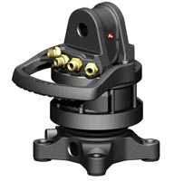 | 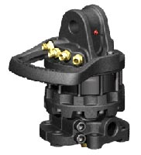
Rotator GR_465 | Rotator GR_55MF
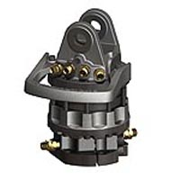
Rotator GR_104DB

